Experiment 15 N.srivaradeepak
Aim 192572075
To implement a Decision Tree using the ID3 algorithm with Entropy and Information Gain for classifying the given weather dataset.

Algorithm
- Enter the weather training dataset.
- Calculate Entropy of the dataset.
- Calculate Information Gain for each feature.
- Select the feature with the highest Information Gain.
- Split the dataset based on the selected feature.
- Repeat the process until the decision tree is completed.
- Display the constructed Decision Tree.

Program
import math

# Training data
dataset = [
['Sunny', 'Hot', 'High', 'Weak', 'No'],
['Sunny', 'Hot', 'High', 'Strong', 'No'],
['Overcast', 'Hot', 'High', 'Weak', 'Yes'],
['Rain', 'Mild', 'High', 'Weak', 'Yes'],
['Rain', 'Cool', 'Normal', 'Weak', 'Yes'],
['Rain', 'Cool', 'Normal', 'Strong', 'No'],
['Overcast', 'Cool', 'Normal', 'Strong', 'Yes'],
['Sunny', 'Mild', 'High', 'Weak', 'No'],
['Sunny', 'Cool', 'Normal', 'Weak', 'Yes'],
['Rain', 'Mild', 'Normal', 'Weak', 'Yes'],
['Sunny', 'Mild', 'Normal', 'Strong', 'Yes'],
['Overcast', 'Mild', 'High', 'Strong', 'Yes'],
['Overcast', 'Hot', 'Normal', 'Weak', 'Yes'],
['Rain', 'Mild', 'High', 'Strong', 'No']
]

features = ['Outlook', 'Temperature', 'Humidity', 'Wind']

def entropy(data):
total = len(data)
counts = {}

for row in data:
label = row[-1]
counts[label] = counts.get(label, 0) + 1

ent = 0
for count in counts.values():
p = float(count) / total
ent -= p * math.log(p, 2)

return ent

def information_gain(data, feature):
total_entropy = entropy(data)
values = {}

for row in data:
values.setdefault(row[feature], []).append(row)

weighted_entropy = 0

for subset in values.values():
weighted_entropy += (float(len(subset)) / len(data)) * entropy(subset)

return total_entropy - weighted_entropy

def build_tree(data, feature_names):
labels = [row[-1] for row in data]

if labels.count(labels[0]) == len(labels):
return labels[0]

if len(feature_names) == 0:
return max(set(labels), key=labels.count)

gains = [information_gain(data, i) for i in range(len(feature_names))]
best_feature = gains.index(max(gains))

tree = {feature_names[best_feature]: {}}

values = set(row[best_feature] for row in data)

for value in values:
subset = []

for row in data:
if row[best_feature] == value:
new_row = row[:best_feature] + row[best_feature + 1:]
subset.append(new_row)

new_features = feature_names[:best_feature] + feature_names[best_feature + 1:]
tree[feature_names[best_feature]][value] = build_tree(subset, new_features)

return tree

tree = build_tree(dataset, features)

print("Decision Tree:")
print(tree)

Output
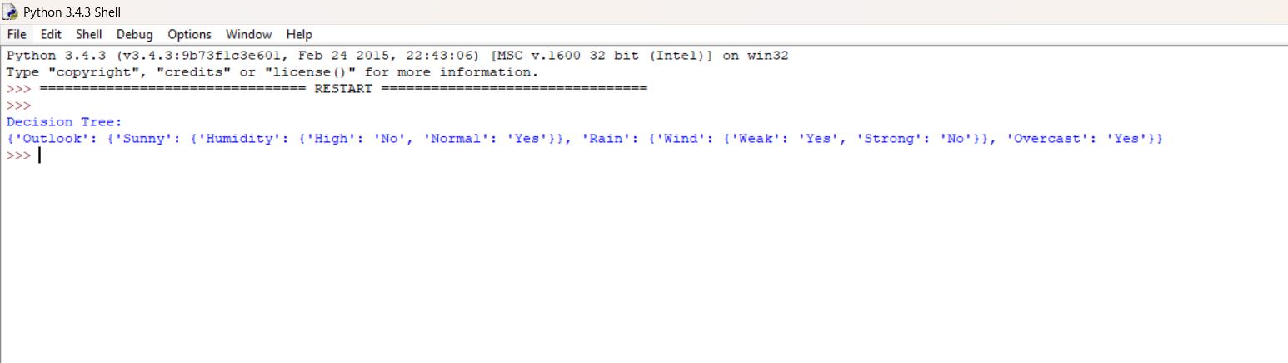

Result
The Decision Tree classification model was successfully implemented using Entropy and Information Gain, and the weather dataset was classified into Yes/No categories.

